logo-concordia-university-montreal.png

Project Release Summary

GitHub Repository Monitoring Tool

(<https://github.com/abhandal/SOEN341-G4)>



© Charles-Philippe Labbé, Batoul Yehia

Professor: Dr. René Witte, P.Eng.

Teacher assistant: Tamara Dittimi

Team 4

|  |  |  |  |
| --- | --- | --- | --- |
| Name | Student id | GitHub  Username | Number of story points |
| Nikita Baranov | 40012854 | [NikitaBaranov](https://github.com/NikitaBaranov) |  |
| Aman Bhandal | 27390858 | [abhandal](https://github.com/abhandal) |  |
| Raymart De Guzman | 40010443 | [tramyardg](https://github.com/tramyardg) |  |
| Dmitry Kryukov | 40029645 | [b5n](https://github.com/b5n) |  |
| Charles-Philippe Labbé | 40002442 | [CharlesPhilippeLabbe](https://github.com/CharlesPhilippeLabbe) |  |
| Andy Pham | 40006071 | [andypham29](https://github.com/andypham29) |  |
| Ksenia Popova | 40029623 | [Lyncis](https://github.com/Lyncis) |  |
| Batoul Yehia | 40010912 | [batoulyehia](https://github.com/batoulyehia) |  |

Montreal, QC, Canada

2017

# Project summary:

The GitHub repository monitoring tool helps the teaching assistants to monitor and grade each group and student, by analyzing a repository information in an easy-to-use and easy-to-understand way.

# Main Features:

* Secure login with GitHub account
* Get an information from available repositories
* Show the information in a convenient way (text, charts ... ):
  + Contributors (students):
    - a number of events: overall and per student
    - a percentage of events per student
  + Events: Commits, Pull requests, Issues, Comments
* Write a feedback from TA that will be stored in teams’ repositories

# Velocity and a list of user stories and non-story tasks for each Sprint: (For user story list with screenshots see Appendix 1)

|  |  |  |  |  |
| --- | --- | --- | --- | --- |
|  | | | Story points | Stories |
| **Total:** | | | **55** | **20** |
| [**Sprint 1**](https://github.com/abhandal/SOEN341-G4/milestone/3) | | | **9** | **3** |
|  | GitHub Java API Test | 3 |  |  |
| GitHub PHP API Test | 3 |  |  |
| Chart libraries Test | 3 |  |  |
| [**Sprint 2**](https://github.com/abhandal/SOEN341-G4/milestone/4)**,** [**part1**](https://github.com/abhandal/SOEN341-G4/milestone/5) | | | **18** | **8** |
|  | Log In | 3 |  |  |
| Events Separation | 3 |  |  |
| Adding repositories | 2 |  |  |
| Generation Information | 3 |  |  |
| Overall Report | 2 |  |  |
| Function of Activity Percentage | 2 |  |  |
| Tabs | 2 |  |  |
| Data Selection | 1 |  |  |
| [**Sprint 3**](https://github.com/abhandal/SOEN341-G4/milestone/6) | | | **14** | **5** |
|  | Selecting Repository | 5 |  |  |
| Sorting the information of the user interface | 1 |  |  |
| Weekly Report | 3 |  |  |
| Implement a graphing tool | 3 |  |  |
| Report Type | 2 |  |  |
| [**Sprint 4**](https://github.com/abhandal/SOEN341-G4/milestone/7) | | | **7** | **2** |
|  | Burndown Chart | 4 |  |  |
| Comments | 3 |  |  |
| [**Sprint 5, Release**](https://github.com/abhandal/SOEN341-G4/milestone/8) | | | **7** | **2** |
|  | Create Tests | 4 |  |  |
| Create Project Report | 3 |  |  |

# Overall Arch and Design

The system utilizes the Client-Server Architectural Pattern.

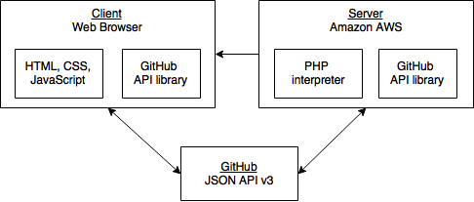

# Infrastructure

Server side:

* PHP ([http://php.net](http://php.net)))

PHP makes it easy to work with headers, allowing the authentication of a user to be written with less code. It also allows to pass the information of a repo in the header (such as the name of the repo and the owner).

* Composer (<https://github.com/composer/composer>)

The Composer was needed to make a request to the Github api for the authentication of the user. By doing it this way, it allowed to store the Github oauth token in a user session which is useful for passing information from one page to another.

* Amazon Web Services (AWS) (<https://aws.amazon.com>)

Free of charge and reliable web hosting with PHP support.

Client side:

* HTML, CSS ([https://www.w3.org/html](https://www.w3.org/html/))
* JavaScript (<http://www.ecmascript.org>)
* Chart.js (<http://www.chartjs.org>)

Open source simple and flexible JavaScript charting library.

* JQuerry.js (<https://jquery.com)>

Fast, small, and feature-rich JavaScript library for HTML document traversal and manipulation, event handling, animation.

* Material Design (<https://material.io)>

Simple, ready to use UI library.

* Bootstrap (<http://getbootstrap.com)>

JavaScript framework for developing responsive website.

* Github.js (<https://github.com/github-tools/github)>

This Github API wrapper handles the method calls and promises very well, and is very easy to understand. Other Javascript wrapper needed Node.js, but this one only required JQuery.

Continuous Integration environment:

Travis CI (<https://travis-ci.com)> - Free for students flexible testing tool with immediate repetitive testing.

The Project testing environment - <https://travis-ci.com/abhandal/SOEN341-G4>

Tests run via node.js (<https://nodejs.org>):

* for Integration tests, we use Mocha(<https://mochajs.org>) and Selenium(<http://www.seleniumhq.org>)
* for HTML and JavaScript syntax checking we use ESLint (<http://eslint.org>)

Unit tests are run by QUnit (<https://qunitjs.com)>

<https://github.com/abhandal/SOEN341-G4/blob/master/test/unit/test.html>

# Name Conventions

The code conventions of the Java programming language were followed: (<http://www.oracle.com/technetwork/java/codeconvtoc-136057.html>)

# Code

|  |  |
| --- | --- |
| File Path | Purpose |
| Integration/js/repo.js <https://github.com/abhandal/SOEN341-G4/blob/master/Integration/js/repo.js> | Getting the information of the Github API and converting it to useful information. |
| Integration/repoSelection.php  <https://github.com/abhandal/SOEN341-G4/blob/master/Integration/repoSelection.php> | Main application page |
| Integration/admin.php  <https://github.com/abhandal/SOEN341-G4/blob/master/Integration/admin.php> | Handles Github login and session timeout. Sets up objects and variables. |
| Integration/js/addRepo.js  <https://github.com/abhandal/SOEN341-G4/blob/master/Integration/js/addRepo.js> | Lists available repositories and lists all selected repositories on the sidebar. |
| Integration/css/styles.css  <https://github.com/abhandal/SOEN341-G4/blob/master/Integration/css/styles.css> | Creates the style of the project. |

# Testing and Continuous Integration

**5 most important Acceptance tests (full test report See Appendix 2)**

|  |  |
| --- | --- |
| User Story | Expected Results |
| Adding repositories | Add repository to be available in the system. |
| Overall Report | The system should provide the overall report of the repository |
| Weekly Report | The system should provide the weekly splits of overall report of the repository |
| Burndown Chart | The system should provide the burndown chart for the repository |
| Comments | Write a comment and save it to the current repository. |

**5 most important unit test.**

(<https://github.com/abhandal/SOEN341-G4/blob/master/test/unit/test.html>)

|  |  |
| --- | --- |
| Line Number  in unit test file | What is it testing |
| Description Test  Line 26 - 30  See Appendix 3.1 | If the description is empty it will return false, failing the test. Otherwise, it will return true which is a pass. |
| Burndown Test  Line 46 - 50  See Appendix 3.2 | If the burndown data is empty it will return false, failing the test. Otherwise, it will return true which is a pass. |
| Commit Test  Line 60 - 66  See Appendix 3.3 | If the user has 0 or less than 0 commits then the test will fail, since the user does have more than 0 commits in this SOEN341 repo. Additionally, if an undefined user is given then the test will pass as it ensures than an undefined user is caught. |
| Week Test  Line 68 - 73  See Appendix 3.4 | Tests whether there are less than 0 weeks in the first week and if a non-existent week returns undefined. |
| Collaborator Test  Line 52 - 58  See Appendix 3.5 | Tests whether there are 10 collaborators in the SOEN341-G4 repo, in this case there are exactly 10 users within the repo. Additionally, it checks whether there are 0 or less than 0 collaborators within the repo for which if it returns true the test will fail. |

**5 most important integration tests.**

|  |  |
| --- | --- |
| Test File path | What is it testing |
| Tabs test  <https://github.com/abhandal/SOEN341-G4/blob/master/test/integration/tabs_test.js> | The test runs through all the tabs and checks for anchor objects that confirm that this tab works |
| Authorization test  <https://github.com/abhandal/SOEN341-G4/blob/master/test/integration/login_test.js> | The test verifies the authorization of the user with the correct and incorrect credentials |
| Add repo test  <https://github.com/abhandal/SOEN341-G4/blob/master/test/integration/get_repo_test.js> | The test checks to see if the user has at least one repository to add |
| Get issues test  <https://github.com/abhandal/SOEN341-G4/blob/master/test/integration/get_repo_issues_test.js> | The test checks whether it is possible to get an object with the number of issues |
| Get commits test  <https://github.com/abhandal/SOEN341-G4/blob/master/test/integration/get_repo_commits_test.js> | The test checks whether it is possible to get an object with the number of commits |

# Appendix 1 – User Stories

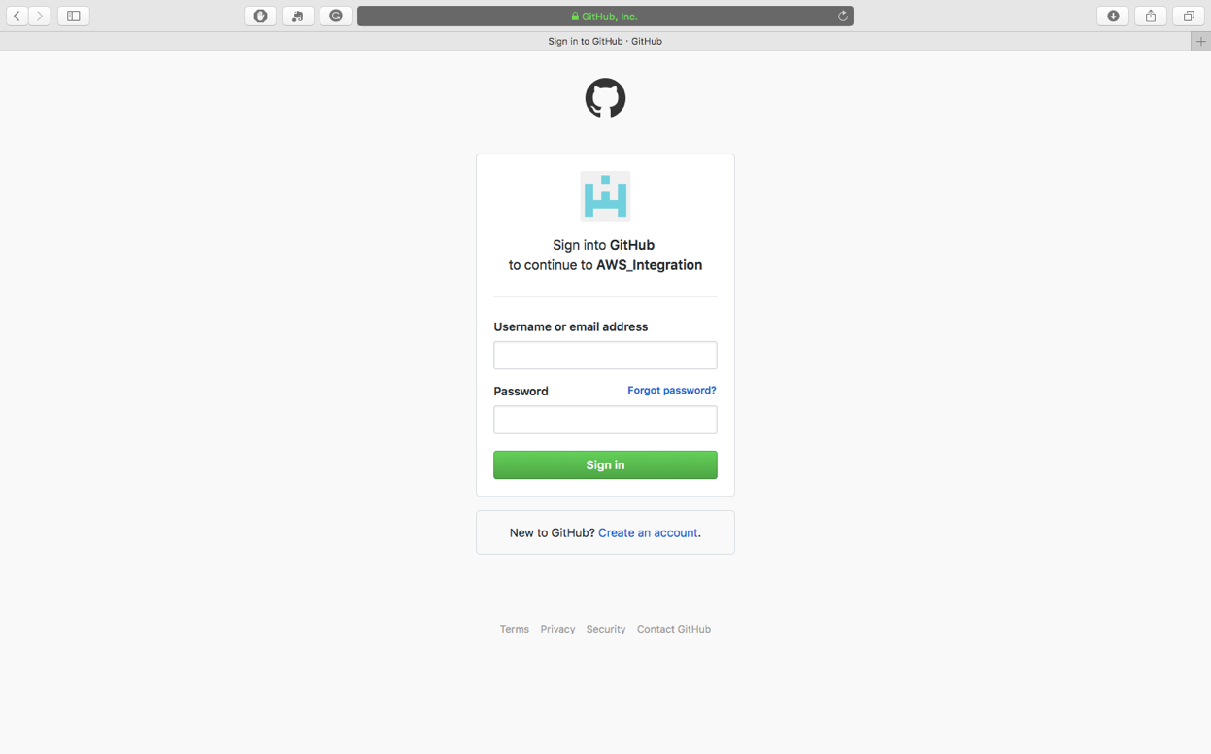Core functions

Figure 1. Login with GitHub credentials.

1. 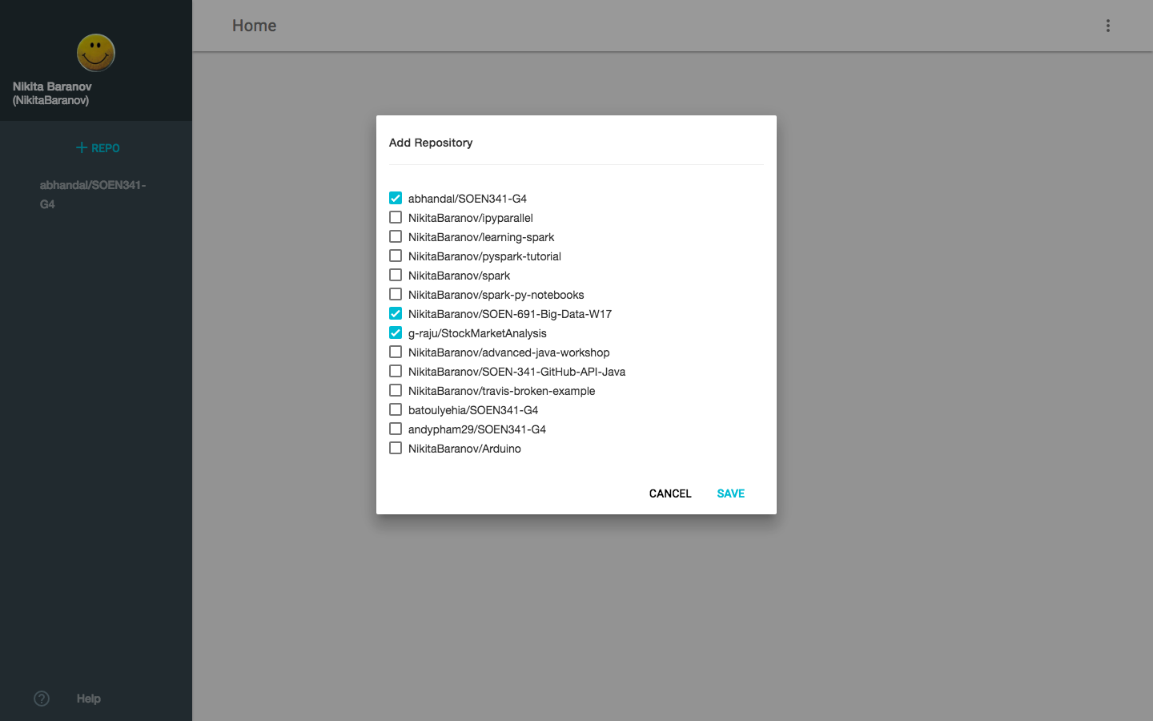Login

Figure 2. Selecting and Adding repositories.

As a user, I want to login using my GitHub account.

1. Adding repositories

As a user, I want be able to add repositories on my page, so its data can be displayed.

1. Selecting Repository

As a user, I want to select a repository from a known GitHub user.

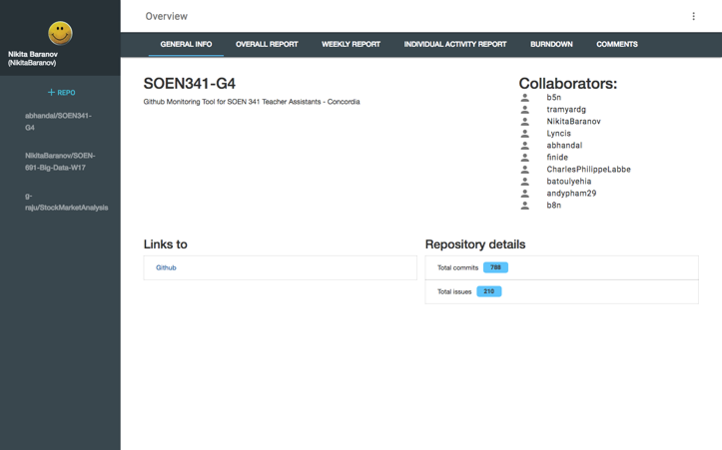

Figure 3. General information. Tabs.

1. Tabs

As a user, I want to see different tabs in order to have access to general information, weekly reports, user reports, burndown chart, and comments.

1. Generation Information

As a user, I want a general information page about a repository.

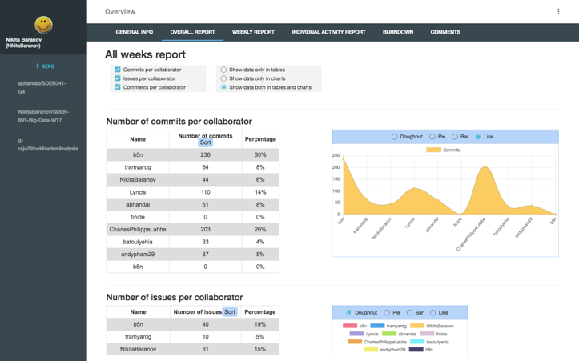

Figure 4. Overall Report.

1. Overall Report

As a user, I want to see an overall report of all the collaborators' activities.

1. Weekly Report

Figure 5. Weekly Report.

As a user, I want to see a weekly report of all the collaborators' activities.

1. 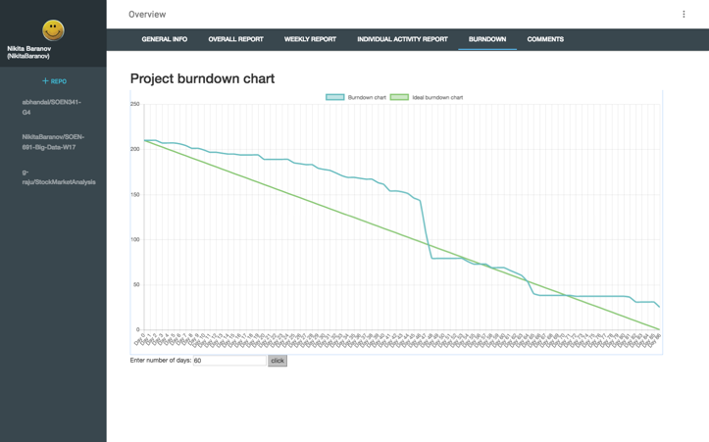Burndown Chart

Figure 6. Burndown Chart

As a user, I want to see the burndown chart of the team.

1. 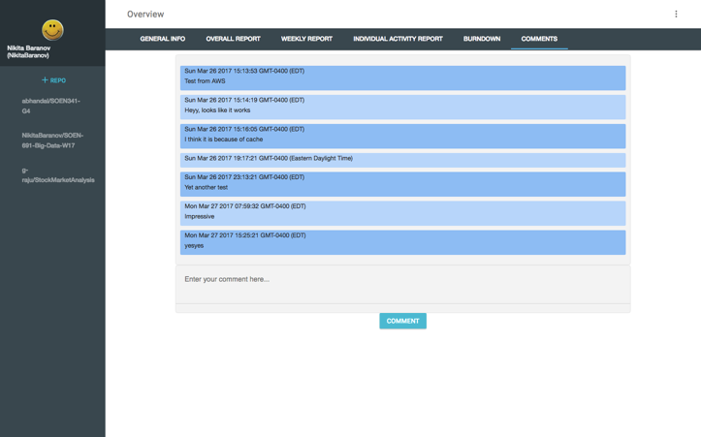Comments

Figure 7. Comments.

As a user, I want to add comments to each repository.

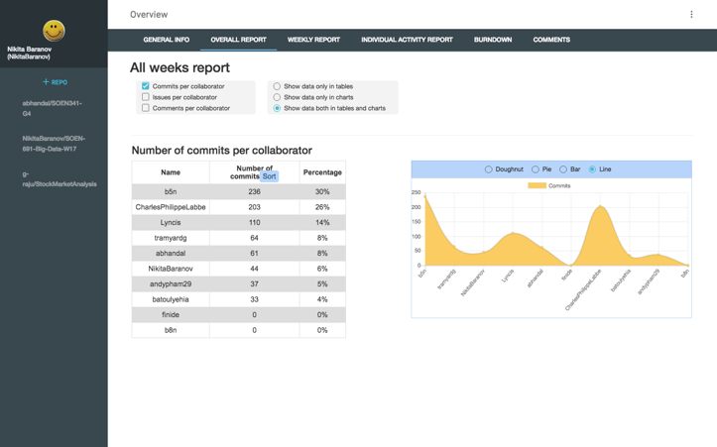

Figure 8. Sorting the information. Percentages, Report Type. Graphical Chart.

1. Sorting the information of the user interface

As a user, I want to sort the charts and the tables from the least commits to the most.

1. Function of Activity Percentage

As a user, I want to see the percentage of each collaborator's activity.

1. Events Separation

As a user, I want to see a separation of events to commits, issues, and comments.

1. Implement a graphing tool

As a user, I want to see the breakdown of events into tables and charts.

1. 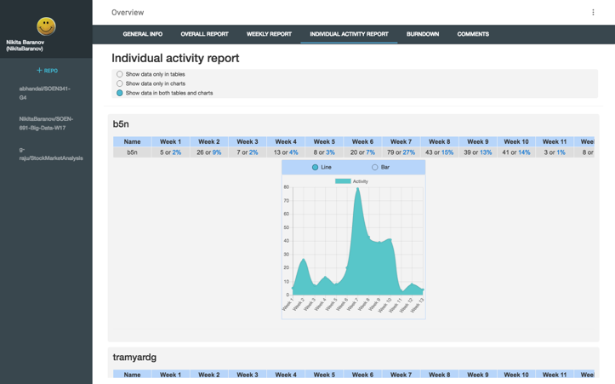Report Type

Figure 9. Individual Report. Data Selection. Report Type.

As a user, I want to choose how the required information will be displayed. In table forms or charts, or both combined.

1. Data Selection

As a user, I want to be able to select the data shown to me.

Extra functions

1. Periodical Email Summaries

As a user, I want the system to send me an email with an overall summary report on activities in repositories so that I can spend less time to get an overall information on a class process.

1. Time Range

As a user, I want to select the time range for the activities for the team and each person: I can select a starting date and an ending date.

1. Separation by sprints

As a user, I want to specify sprints as a time range to be able group information in charts by sprints.

1. Grading space

As a user, I would like to publish grades for each sprint so that the team could see it.

1. Repository Description

As a user, I want to be able create my own description to each repository in my list, that I could recognize repository in my own association.

1. Managing repositories

As a user, I should be able to manage repositories on my page, that I could edit list of repositories.

# Appendix 2 – Final Acceptance Test table.

|  |  |  |  |  |  |
| --- | --- | --- | --- | --- | --- |
| Project: | | GitHub repository monitoring tool | Browser: | Chrome | |
| Written By: | | Nikita Baranov | Description: | Full User story test | |
| Tested By: | | Aman Bhandal | Tested On: | 12-Apr-17 | |
|  |  |  |  |  |  |
| # | Date | User Story | Expected Results | Actual Results | Pass |
| login to the System | | | | | |
| 1 | 12-Apr | Login | Should get to home screen using Github credentials | User logged in using GitHub credentials | Yes |
| 2 | 12-Apr | Selecting Repository | Look through available repositories, select some of them to be available on system. | User got a list of available repositories. Selected 2 and got them available on left panel. | Yes |
| 3 | 12-Apr | Adding repositories | Add repository to be available in the system. | User selected repository to be added and got them available on left panel of the system. | Yes |
| Overall functionality | | | | | |
| 4 | 12-Apr | Tabs | The information should be presented in different tabs | The system has tabs for different reports | Yes |
| 5 | 12-Apr | Generation Information | The system should provide the general information about the repository. | General info seen on the General InfoTab | Yes |
| 6 | 12-Apr | Overall Report | The system should provide the overall report of the repository | Overall report is on the Overall Report Tab | Yes |
| 7 | 12-Apr | Weekly Report | The system should provide the weekly splits of overall report of the repository | Overall report is on the Weekly Report Tab | Yes |
| 8 | 12-Apr | Burndown Chart | The system should provide the burndown chart for the repository | Burndown Chart is on the Burndown chart Tab | Yes |
| 9 | 12-Apr | Comments | Write a comment and save it to the current repository. | Wrote a comment and saved it to the current repository. The page did not refreshed. | Yes |
| The functionality of the Report Tabs | | | | | |
| 10 | 12-Apr | Sorting the information of the user interface | Table with information could be sorted in descending order | The information was sorted by clicking on the Sort button. | Yes |
| 11 | 12-Apr | Function of Activity Percentage | The information should be seen in percentage | The information in tables are shown with percentages. | Yes |
| 12 | 12-Apr | Events Separation | The information should be separated to commits, issues, and comments. | Different events are shown separately. | Yes |
| 13 | 12-Apr | Implement a graphing tool | The information should be presented in graphical view | There is Donut, Pie, Line and Bar charts. | Yes |
| 14 | 12-Apr | Report Type | The required information should be displayed. In table forms or charts, or both combined. | The table and Charts are on the pages. | Yes |
| 15 | 12-Apr | Data Selection | The system should display only selected information. | The information was selected with the checkboxes on the top of the page. | Yes |

# Appendix 3 - Unit Test Code Blocks

1. Code Block 1  
   repo.description.then(function(description) {  
    QUnit.test("details", function(assert){   
    assert.notEqual(description, "", "Description is not empty");  
    });   
   });
2. Code Block 2  
   repo.burndown.then(function(burndown) {  
    QUnit.test("getBurndown", function(assert){   
    assert.notEqual(burndown, "", "Burndown is not empty");  
    });   
   });
3. Code Block 3  
   repo.commits.then(function(commits) {  
    QUnit.test("getCommits", function(assert){  
    assert.notEqual(commits['abhandal'], 0, "Repo 'abhandal' has greater than 0 commits");  
    assert.equal(commits['blablabla'], undefined, "Repo undefined returnes undefined");  
    assert.notEqual(commits['abhandal'], -1, "Repo 'abhandal' does not have less than 0 commits");  
    });   
   });
4. Code Block 4  
   repo.weeklyInfo.then(function(weeks){  
    QUnit.test("getWeeklyInfo", function(assert){  
    assert.notEqual(weeks[0]['abhandal'], -1, "Number of events in first week is not less than 0");  
    assert.equal(weeks[-1], undefined, "Number of events in non-existant week is undefined");  
    });  
   });
5. Code Block 5  
   repo.collaborators.then(function(response){  
    QUnit.test("getCollaborators", function(assert){  
    assert.equal(response.length,10,"There are 10 collaborators in the SOEN341-G4 repo");  
    assert.notEqual(response.length,-1,"There are not less than 0 collaborators in the SOEN341-G4 repo");  
    assert.notEqual(response.length,0,"There are not 0 collaborators in the SOEN341-G4 repo");  
    });  
   });

# Appendix 4 – Challenges and Feedback

# Challenges

Aman Bhandal

The main challenge areas involved setting up the testing environment and assigning story points. The test environment was difficult as it involved learning QUnit, a JavaScript unit testing framework, and creating test cases for each of the JavaScript functions. Learning and understanding the steps involved in setting up QUnit were facilitated by the framework's documentation and assistance from members of our team. Additionally, the creation of test cases were carried out using the partition method which assisted in ensuring that outlier and normal cases were tested accordingly. Another challenge area involved assigning story points to user stories, especially during our first planning poker session where we did not understand our system nor our ability to implement the features. However, as we moved through the sprints and development cycles were able to assign story points more accurately and we were able to deliver on our individual tasks.

Raymart De Guzman

I faced two different challenges during the course of the project. First, learning Material Design Lite (MDL) framework for the front-end development. This is framework is all new to me. However, I did quite a bit of work in Bootstrap, a framework similar to MDL. I've been using Bootstrap in my own projects. So, this was not a surprise for me. It took me a couple of hours to learn the basics and finally applied them to the project. Second, understanding and learning about web application programming interface (API) especially GitHub API. GitHub API is the main web API used in the project, thus, I had to read the API documentation and make sense how are we going to employ their usage in our project. Fortunately, playing around with GitHub's OAuth authorization API helps me understand API application better, as well as its relevance in other projects.

Ksenia Popova

I met a few challenges during this project.

1. Work with Promises when I needed to use the data from them and it was not visible outside Promises.

2. Chart type switch, because I needed to destroy the existing chart before that, but charts plugin.

3. Sorting of the data, because it is represented in object with different properties and it is not possible to make data sorted with one of the object properties.

Dmitry Kryukov

In this project, the main challenges involved experience with asynchronous javascript

and also work with selenium webdriver library for creating integration tests.

I spent a lot of time studying how promises work and how to test asynchronous code.

Charles-Philippe Labbe

The most difficult part of the project, was to learn to work with asynchronous Javascript. Not having a lot of experience with any of the web-programming languages meant that I had to work extra hard to understand the code I was writing and learn how to make it work. At first, I started implementing the backend using PHP, but when it was all done, I realized that it was too slow to convert Github data from JSON to PHP back to JSON objects. Hence, after a couple of weeks of implementing the PHP part of the program, I had to convert everything to Javascript. Since AJAX on its own is not the most convenient way to work with api calls, I opted to go with JQuery. Now it is much faster, but working with promises can be finicky at times.

Nikita Baranov

For me the PHP was and still is the main challenge. At the beginning I have no experience in this language. But, thanks to the other team members, the PHP part was done very quickly. So I can work with JavaScript part. One more think that I have studied during the project is GitHub.

Andy Pham

The usage of the library mdl was a challenge since mdl is not widely used by many developers, there were components that were not compatible with every browser. Some parts are using bootstraps to ensure that the functionality of the web app was available through all browsing platforms. Working with GitHub was also a challenge. I have not worked with any software development platform before. There was a period of time needed to get use to GitHub and to learn the functionality of the website. Another challenge was to work with new concepts such as making API calls.

Batoul Yehia

During this project, I faced several challenges. First, I was not familiar with Git or Github, so I had to learn how to use it. It was completely new to me, so it was a bit difficult at first.

Second, I had to learn frameworks for the user interface. At first I learned how to use Bootstrap, but we had some changes for the project and we ended up changing frameworks, since we switched to Material Design Lite. So, I had to learn how that Material Design Lite worked. Thanks to those, I've gained new knowledge on how to work on and design user interfaces.

# Feedback

Aman Bhandal

The project provided an abundance of experience in the realm of software development and enforced the importance of project planning. This was my first time using the agile development method and working with a large team in developing an application from the ground up. Our team's ability to effectively coordinate tasks and utilize the strengths of individual team members allowed for a seamless planning and implementation of the e-learning application. Due to the positive impact of this project I will use the methods learned and utilize it in future development projects.

Ksenia Popova

This project was a very valuable experience for me for many reasons. First of all, I improved my skills in Javascript. My task was to display the data from the GitHub with charts and tables, so I needed to figure out how to do it and create some algorithms. Secondly, the project idea was to apply Scrum model to our development process, and this should be a very useful experience in the future. And finally, we have a great team. We had a lot of meetings and communicated with Slack, so we always stayed in touch. Everyone could get help with any part of the project and everyone did what he was supposed to do. We completed everything on time without any conflicts or delays, what is why I am very satisfied with this project.

Charles-Philippe Labbe

Overall, I found this project very fulfilling for many reasons. Primarily because I did not have any experience with web development; and because I never worked with external libraries and APIs before. These two reasons in particular meant that I had to work overtime in certain cases, but it was enjoyable nonetheless.

Dmitry Kryukov

I received a lot of useful experience during this project. It was a good work such as a team on a real project, I got a lot of experience in the software development, upgraded skills in JavaScript and knew a lot of new about testing, improved my communication skills. We were working together without conflicts and I was enjoying the project all the time.

Nikita Baranov

The project gave me real hands-on experience of the team software development process. I cannot say that we really tried true Agile, but I guess it is exactly how it is happening is the industry.

Raymart De Guzman

This project has introduced me to the latest web standards such as MDL framework and web API technology. I could not have learned these technologies on my own without being exposed to a project like this. In addition, the project has also taught me how agile methodologies work and applied in a project to produce a working software in a short period time. Overall, this has been a fantastic project to be a part of. It has been a pleasure working with the team who could not have been more helpful.

Andy Pham

Overall, I was able to learn a lot from this project. From the usage of libraries

such as mdl and bootstraps, to understanding the concepts of API calling, this project

allowed me to experience an environment similar to industrial software development.

It also enabled to apply concepts of software development and planning learnt in class.

Batoul Yehia

This project allowed me to work with people I've never met before. This is also my first time working in a large team for programming, whereas I usually program alone or in pairs. This is the kind of experience I need in order to work in software development industries. The team members were very kind and helpful. Thanks to this project, I learned and applied agile planning, and gained even more experience

in web programming than I already had. I'll be able to work with frameworks from now on.